Ex1

3 use <make> system will find makefile file auto in current dir

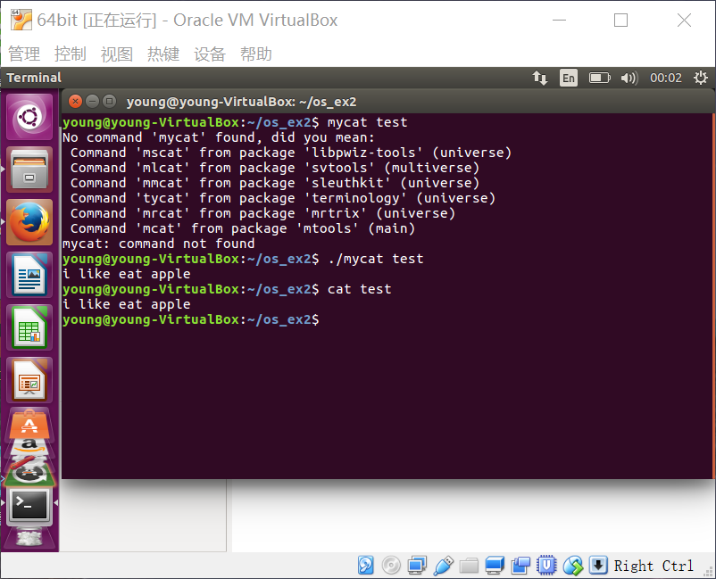

Has the same effect with <cat> command

4.use redirection “>” command

5. 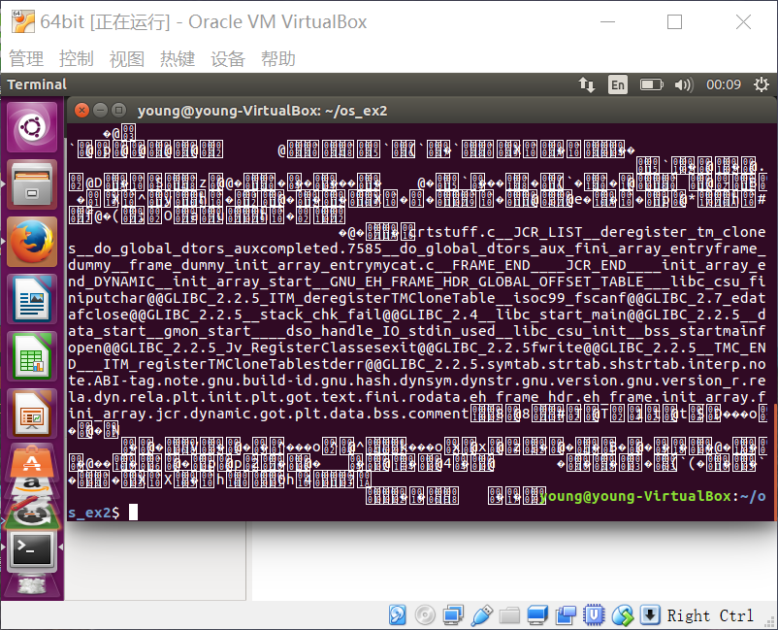

We got unknow information because the not suitable format translation.

Ex2

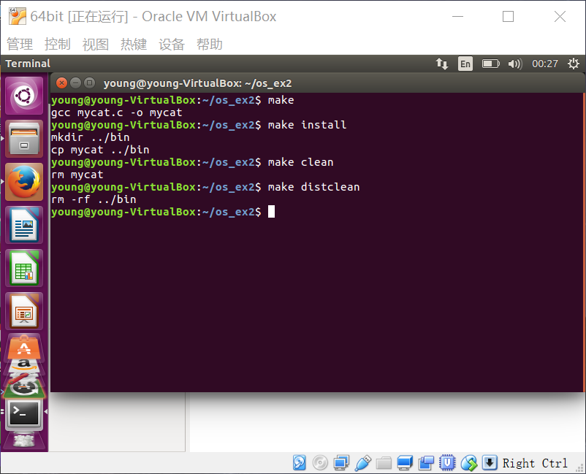

Attention to how to execute make file

Ex3

1. Yes it works. text file is welcome

3.<diff> return nothing is two files are equal. Return message if they are different.

Ex4 ？

Haven’t got what to do…

Ex5

Cat >

Cat >>

Ex6

1 cp -rf

2 rm -rf

3 mv backup origin

Ex7

1. Ls -ali
2. Umask is the method to set user permissions
3. 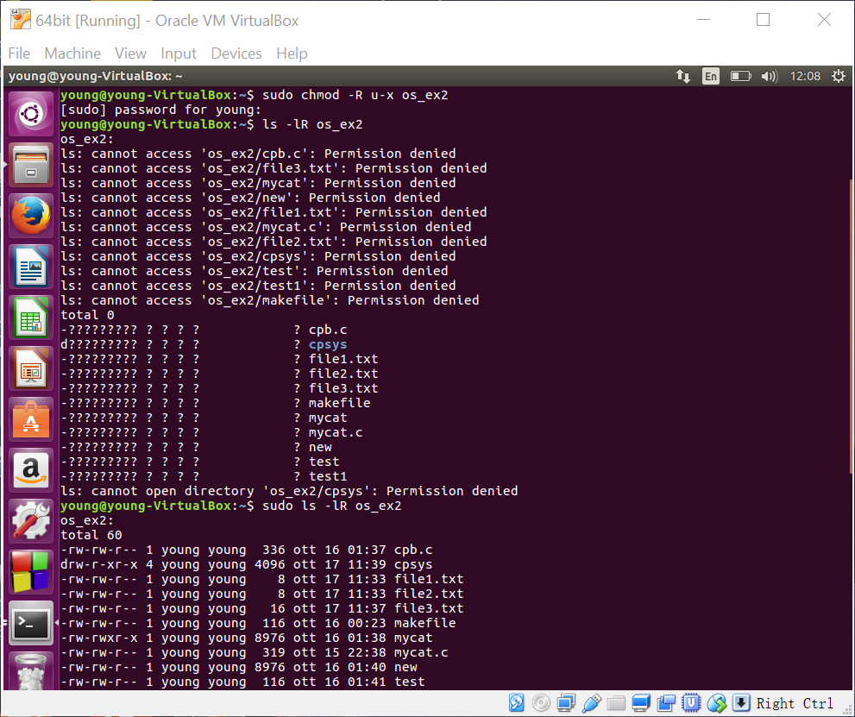

Chmod -R u+x

The execute permission for a file is to access it. If I delete the x permission we will see ??? like figure above.